* **K-Nearest Neighbour** is one of the simplest Machine Learning algorithms based on Supervised Learning technique.
* K-NN algorithm assumes the similarity between the new case/data and available cases and put the new case into the category that is most similar to the available categories.
* K-NN algorithm stores all the available data and classifies a new data point based on the similarity. This means when new data appears then it can be easily classified into a well suite category by using K- NN algorithm.
* K-NN algorithm can be used for Regression as well as for Classification but mostly it is used for the Classification problems.

Advantages of KNN Algorithm:

* It is simple to implement.
* It is robust to the noisy training data
* It can be more effective if the training data is large

Disadvantages of KNN Algorithm:

* Always needs to determine the value of K which may be complex some time.
* The computation cost is high because of calculating the distance between the data points for all the training samples.

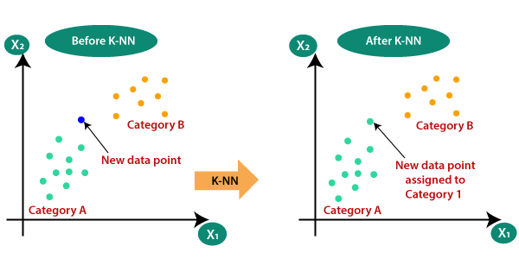

## confusion matrix

It is a matrix of size 2×2 for binary classification with actual values on one axis and predicted on another.

|  |  |
| --- | --- |
| TP | FP |
| FN | TN |

**Precision**

Out of all the positive predicted, what percentage is truly positive.

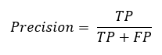

**Recall**

Out of the total positive, what percentage are predicted positive. It is the same as TPR (true positive rate).

